Margaret Shimerdla

Module 11.2 Assignment

CSD340-HTML and CSS

URL: GitHub Page Website

[Margaret Shimerdla CSD 340 Landing Page (venus51882.github.io)](https://venus51882.github.io/csd-340/)

HTML and JavaScript

<!DOCTYPE html>

<html lang="en">

<head>

<title>"CSD 340 Web Development with HTML and CSS"</title>

</head>

<body>

<header>

<h1>Assignment 11.2:JavaScript-Part 3</h1>

</header>

<p>Enter an item for the list in the text box. <br>

Then click the add button to add item to the list.<br>

Then click the delete last entry button to delete the last button.<br>

Then click the display button to display the items on the list.<br></p>

<input type="text" id="userInput" placeholder="Enter an Item">

<button onclick="addItem()">Add</button>

<button onclick="deleteItem()">Delete Last Entry</button>

<button onclick="displayItem()">Display</button>

<hr>

<div id = "output"></div>

<script>

//object

const item = [];

//add item

function addItem(){

const userInputValue = document.getElementById('userInput').value;

item.push(userInputValue);

alert('Item '+userInputValue+' is added at position '+item.length);

}

//delete item

function deleteItem(){

if (item.length>0){

item.pop();

alert ('Deleted. Items left on list: '+item);

}

else{

alert('No item to delete.');

}

}

//display items

function displayItem(){

const outputDiv = document.getElementById('output');

outputDiv.innerHTML = '';

for(let i = 0; i<item.length;i++){

const listItem =document.createElement('p');

listItem.textContent = 'Item '+[i+1]+(' : ')+(item[i]);

outputDiv.appendChild(listItem);

}

}

</script>

</body>

</html>

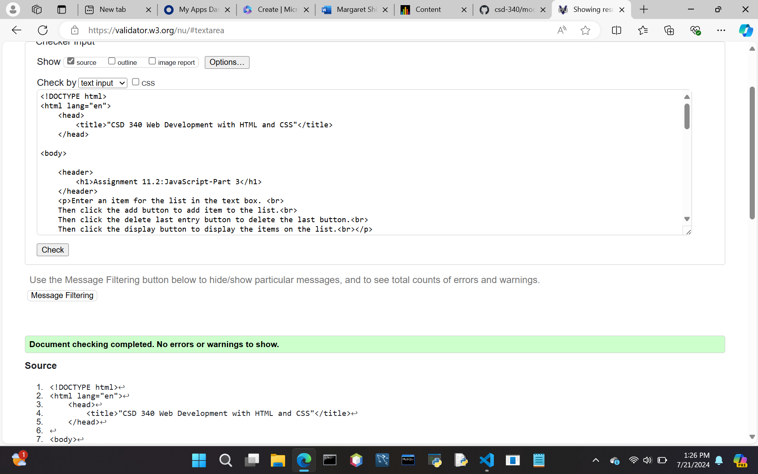

OUTPUT:

